**2023 European Mid-Amateur Championship**

Golfbox Livescoring Application

All participants will receive an email with information about the competition (date, tee times, starting hole for shotgun) and a **link** to enter their scores.

One player per group can entre all scores for the group.

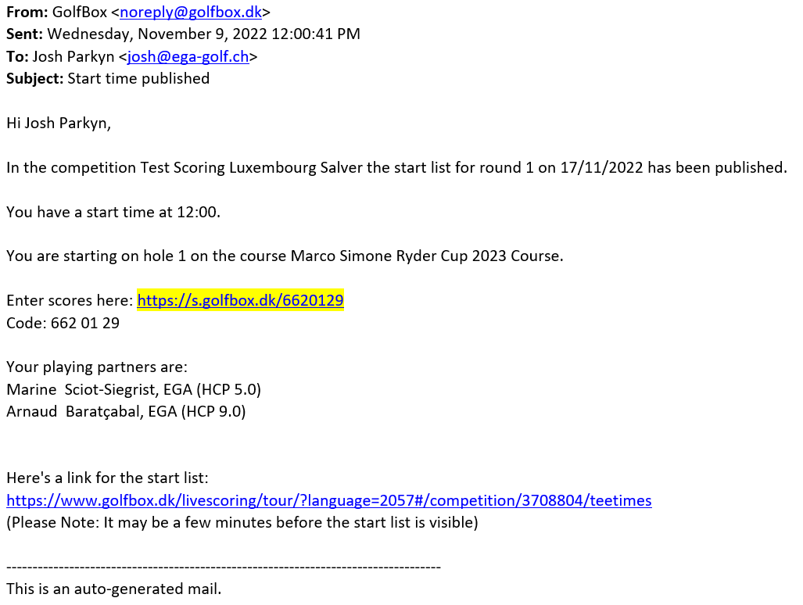

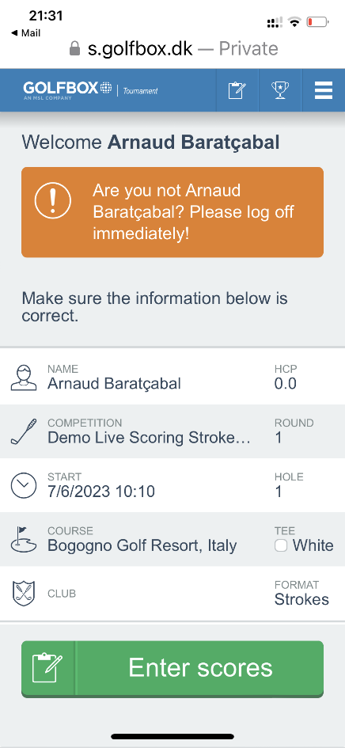By clicking on the link (highlighted above), you will be redirected to your respective profile on GolfBox. Participant must check that all data is correct.

Click on the “ENTER SCORES” button to access the scores’ entering tool.

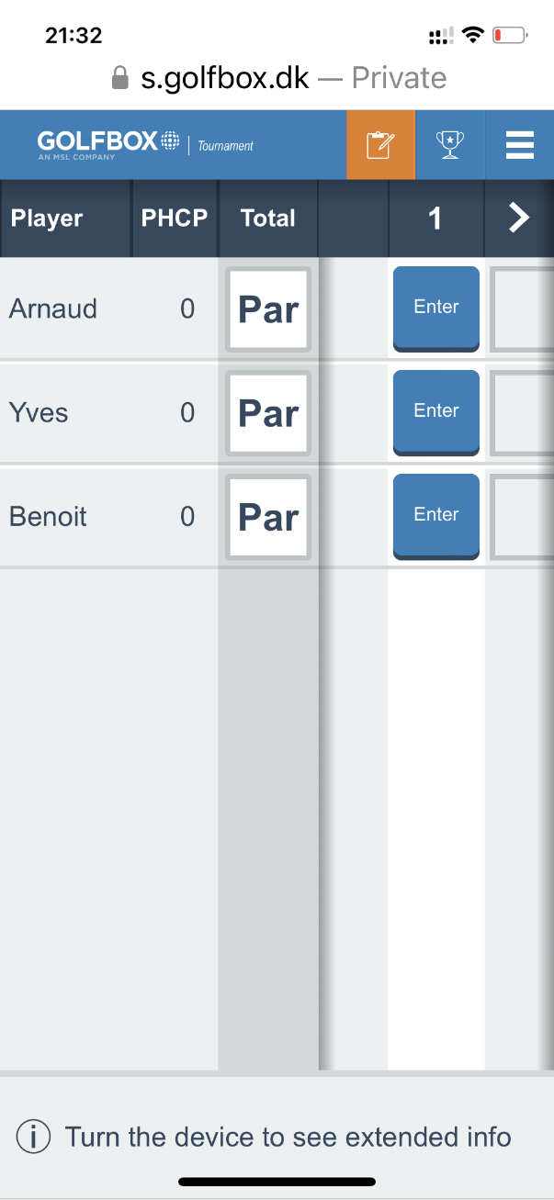By clicking on “enter” , a new page opens with a keyboard with all needed figures.

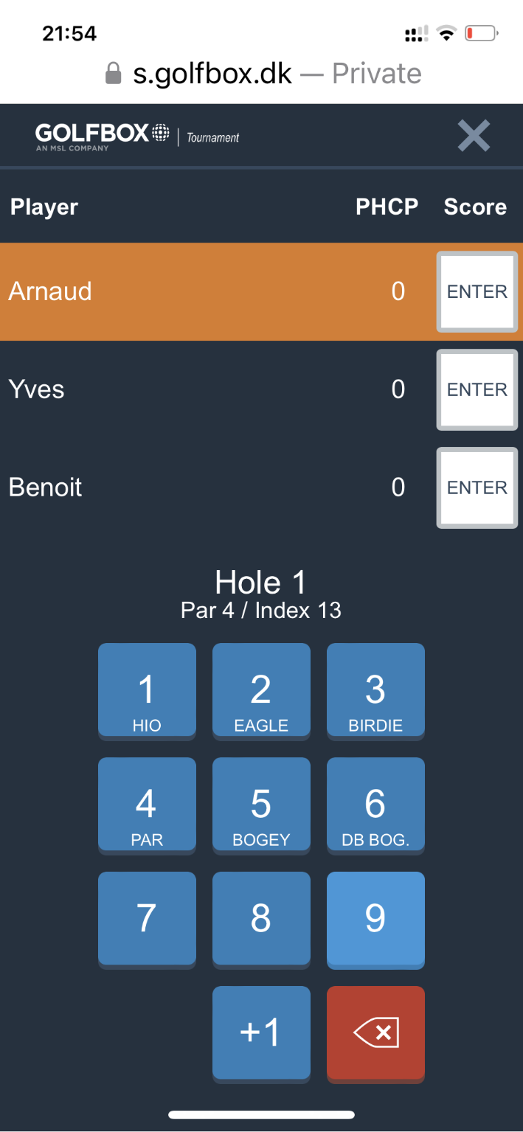

Once all three scores are entered, the system shows the next hole, and so on until 18.

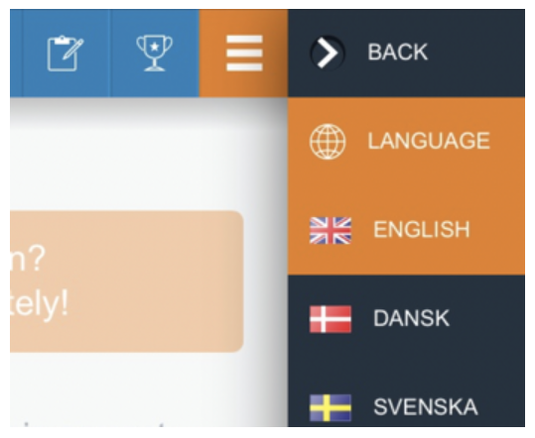The Menu allows you to change the **language** of the page if you prefer:

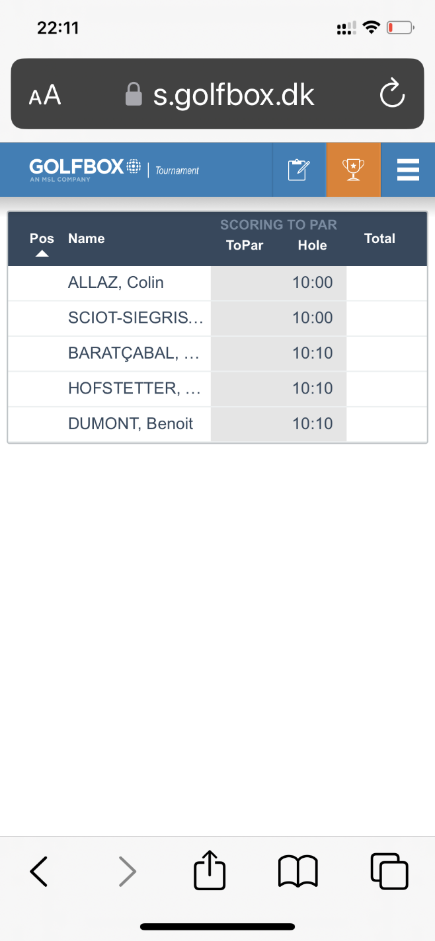The Menu also allows you to see the **leaderboard** with the live Scoring

**If you have any issue call**

**+41 79 389 09 99**

**Many thanks for your assistance**.